Users

Users page is a group of list of employees who for the company. There are many options provided in the users module.

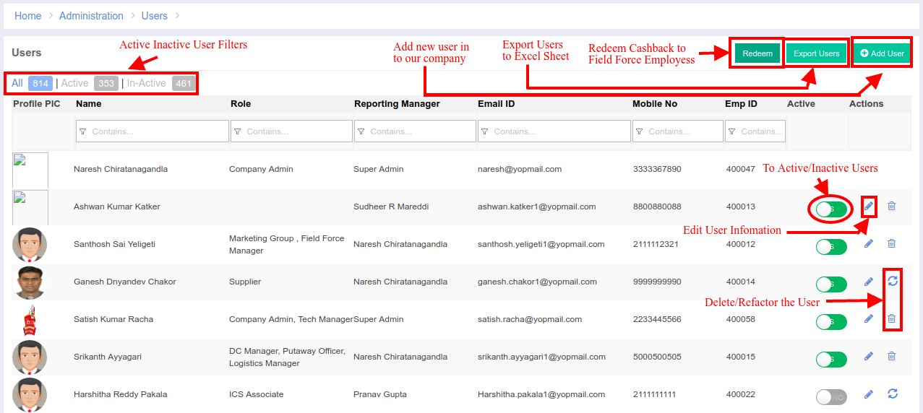

Add new User Page:

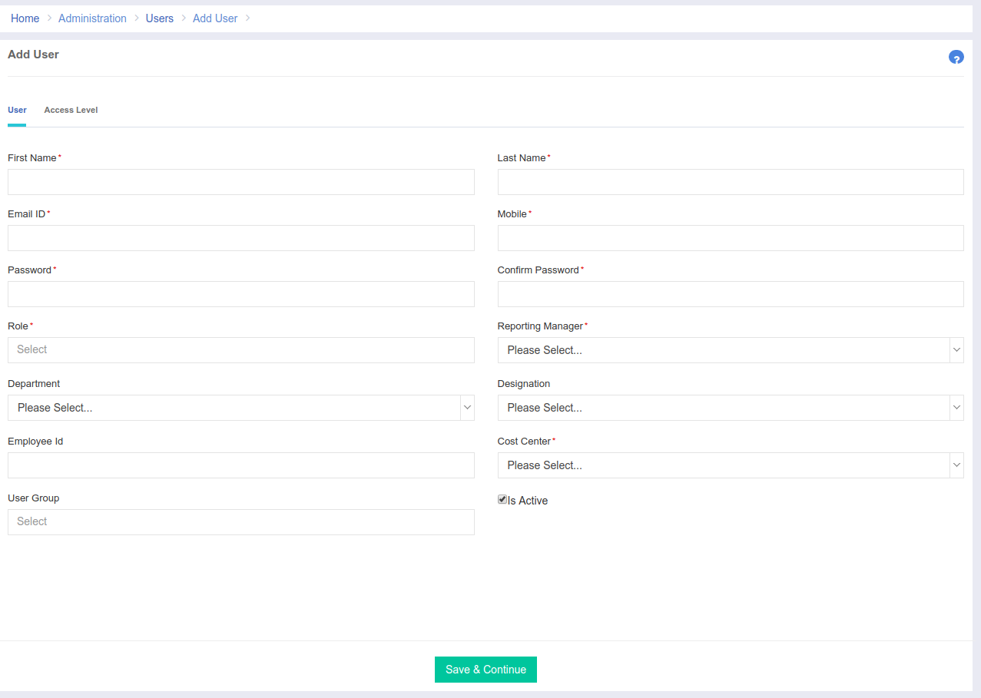

Access Level Tab:  
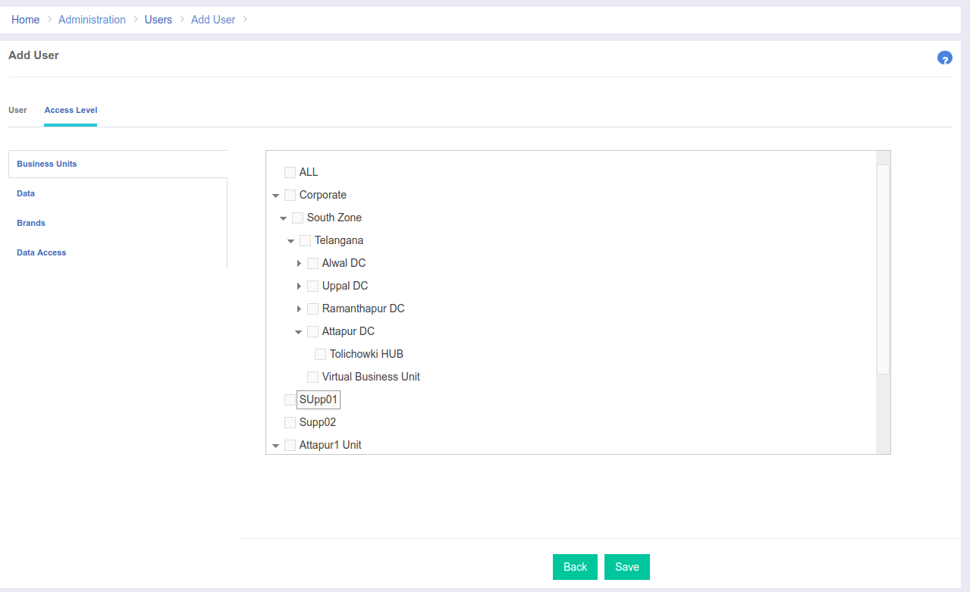

Edit User Page:

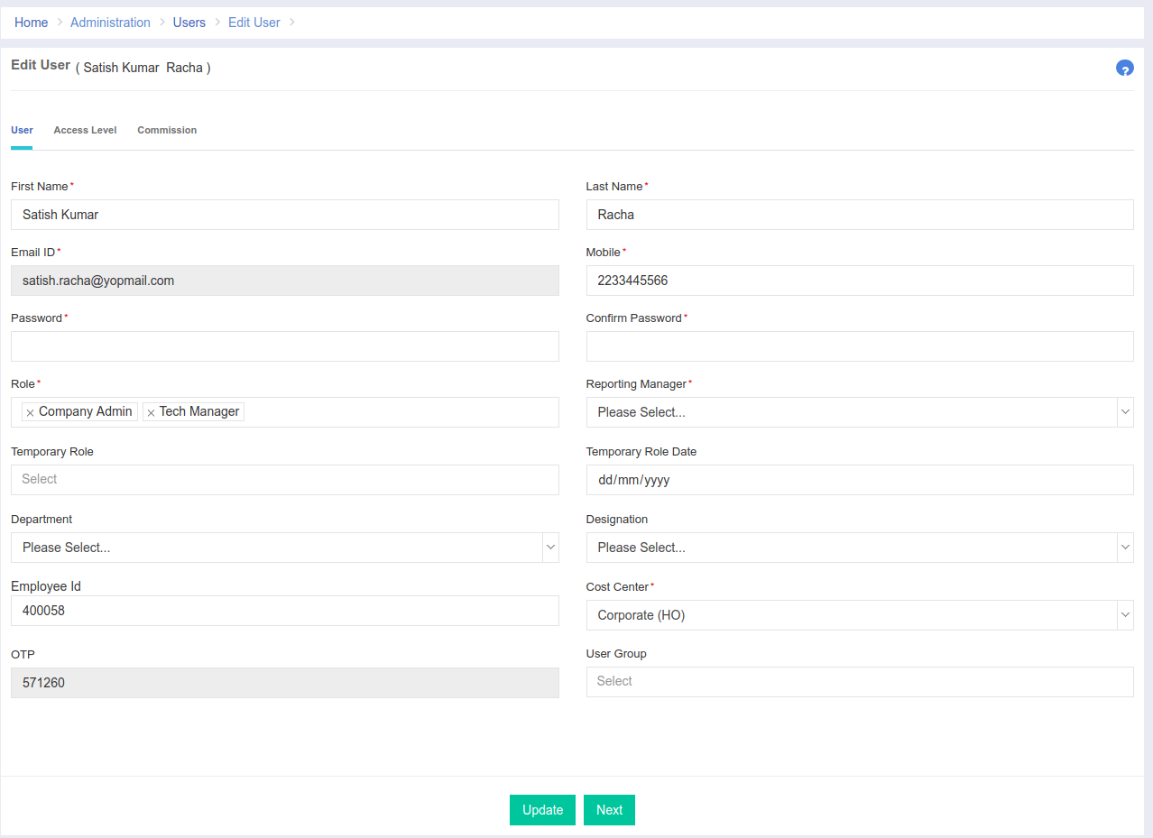

Edit User Access Level Page:

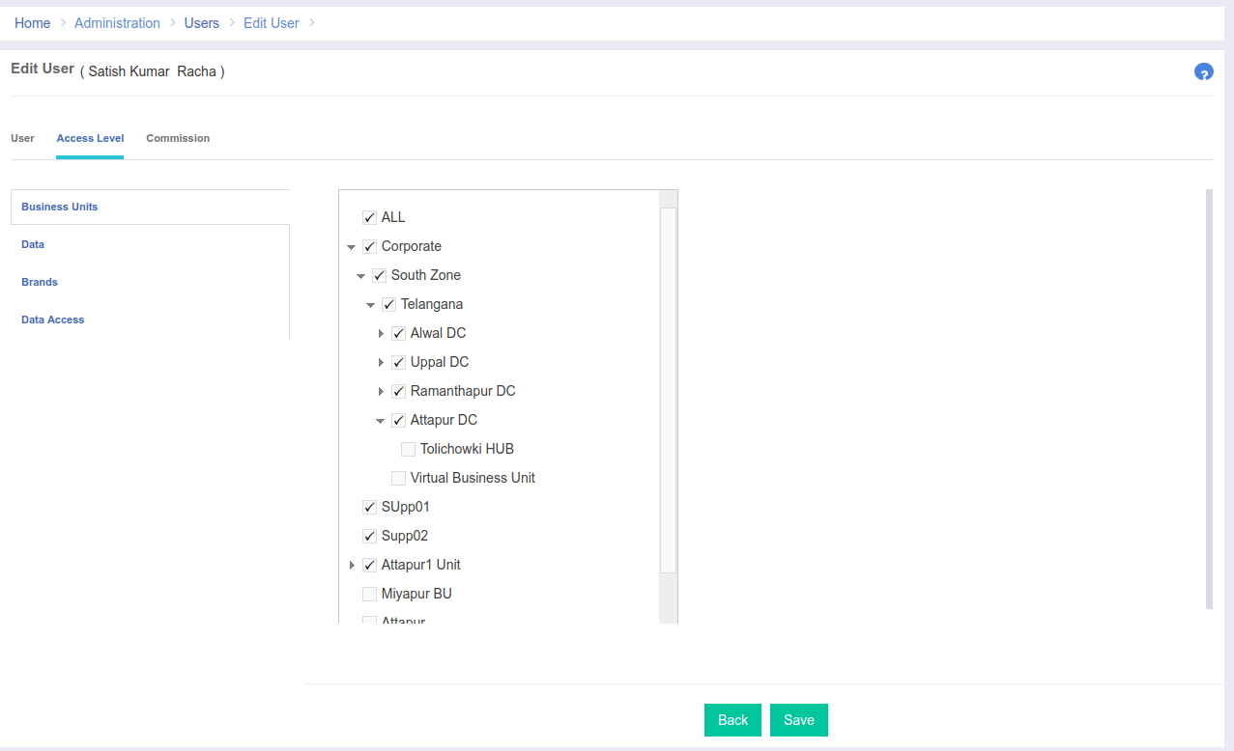

Edit User Commission Page:  
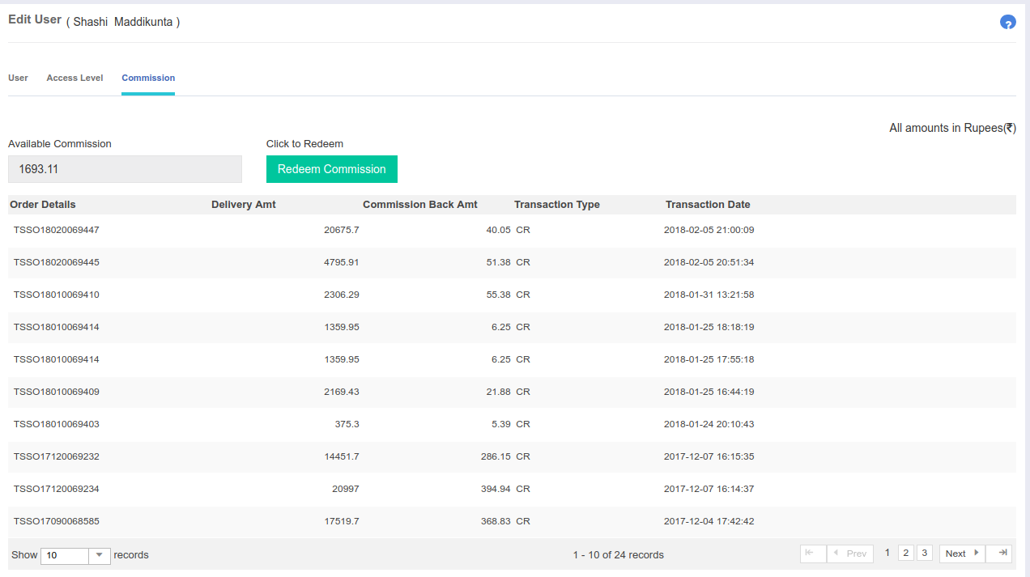  
  
**Code Details:**  
**-> Add New User Page**   
 Url: <http://portal.ebutor.com/users/addusers>  
 Feature: To Add New User [USR002]  
 Description: When we click on add new user button, it will trigger the **addUsers()** method and that will create a view to add new user. Later, when the user enters all the required information, then the user will press the save button, and that will make an ajax call to **saveUser()** method which will validate the input and later, it will make an entry in the users table, then the user can specify the access list to the new user like Business Unit, Data and Brands and the user is needed to check the list checkbox. Finally, the user can save the entered details and can exit the page.

**-> Edit Existing User Page**  
 Url: http://portal.ebutor.com/users/editusers/<encoded_string _of_user_id>

Feature: To Edit Old User [USR003]  
 Description: When the user clicks a particular, user record to edit, then it will trigger the **editUsers()** method which will retrieve all the required information for that user from the database and there we can update the user related data and also access level, and this will **updateUser()** method.

**-> Edit User Commission Page**  
 Url: http://portal.ebutor.com/users/editusers/<encoded_string _of_user_id>

Description: The commission tab is only used for the field force employees. Whenever any field force employee places an order for a commission, then that entry will be displayed here. In this tab, we can redeem the commission for any FF Employee.  
**-> Temporary Role for a User** Feature: To assign temporary role [USRTEMP1]  
 Description: Temporary role is just like any other normal role but with a expiry date. Whenever the admin assigns any temporary role for any particular user, by default the role will be assigned for that user for 1 week from the date of assignment, the admin can even customize the expiry date.   
  
**User All Features List:**

|  |  |  |
| --- | --- | --- |
| **S.No** | **Feature Name** | **Code** |
| 1 | To Assign Business Units | USR007 |
| 2 | To Assign Roles | USR008 |
| 3 | To Redeem Commission for FF | USRFF01 |
| 4 | To Add New User | USR002 |
| 5 | To Generate Excel Report of Users List | USR005 |
| 6 | To Edit User | USR003 |
| 7 | To Delete User | USR004 |
| 8 | To Activate User | USRA01 |
| 9 | To Assign Temporary Role | USRTEMP1 |